To access the electronic holiday form please follow the link:    <http://212.72.152.196/hrsystem/>

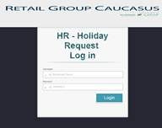

The login is your name and surname as it stays on your email account (for example sopo.murusidze ), the password is standard 123 for everyone, that should be changed immediately.

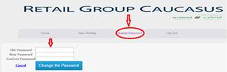

To create the electronic holiday it should be chosen New holiday

cid:image006.jpg@01CFF532.0BD0D8C0

and select the relevant month for the holiday. The whole calendar month will be displayed and it should be selected the specific dates by ticking the relevant boxes for the days. Weekends and public holidays are already entered in the system and are not taken into account while calculating the holidays.

Once the dates are chosen, the “continue” button should be pressed.

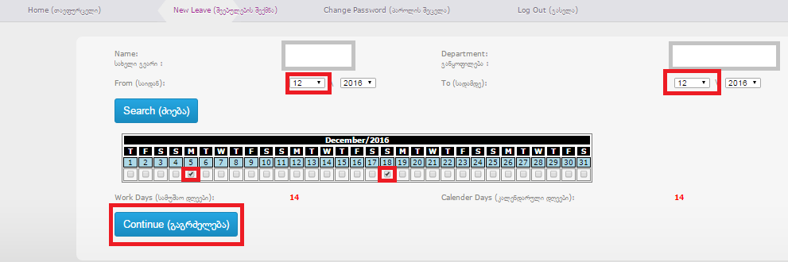

DO-s and LD-s should be selected during the vacation time. Please Note that only one DO can be chosen during one week. (the only exception is if the week contains public holiday, is this case you’ll be able to choose another DO)

Once the Dos and LDs are chosen, the “continue” button should be pressed.

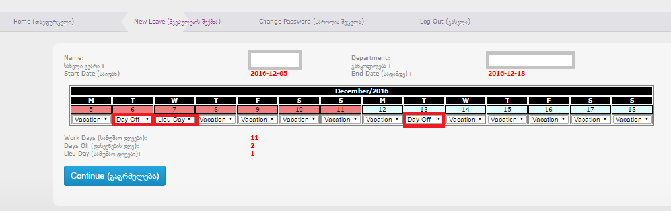

Leave type (Paid Leave, Unpaid leave and etc.) should be selected. After all the information is filled “Create” button should be pressed and vacation will be filled in timeline.

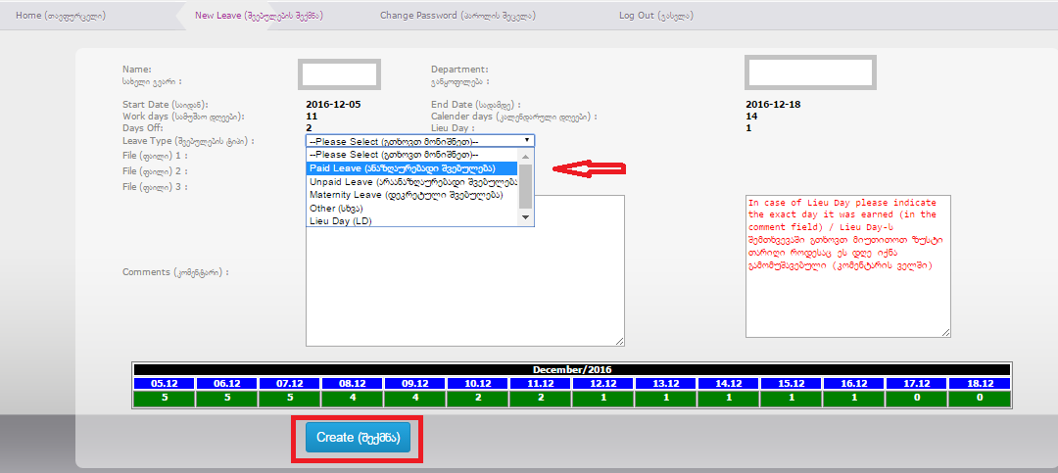

The request will be sent automatically to your Line manager and HR department, who authorize the request.

motion (what makes it easy to track the leave status) and final confirmation will come once vacation form is approved. Do not book any flight or travel until you have received this confirmation.

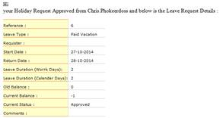

HR team will be assisting with any questions and support while filling the forms if required,

Best regards,

HR Team